**In build server configure Ansible manually**

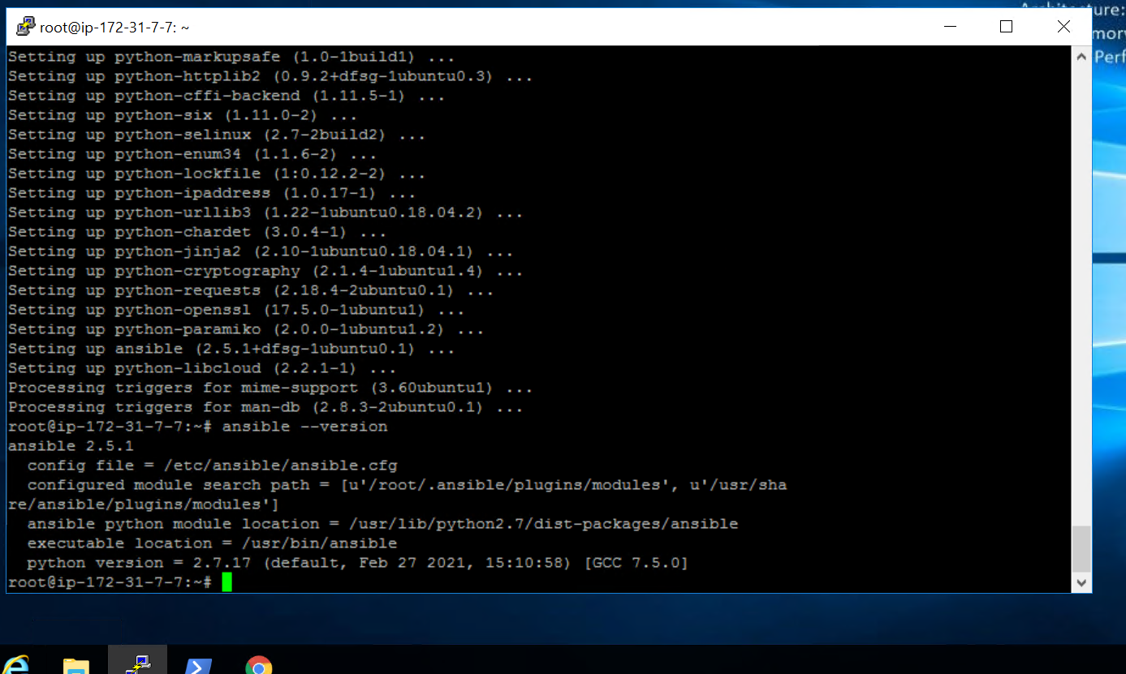

**Modify ansible.cfg to use hosts file as inventory**

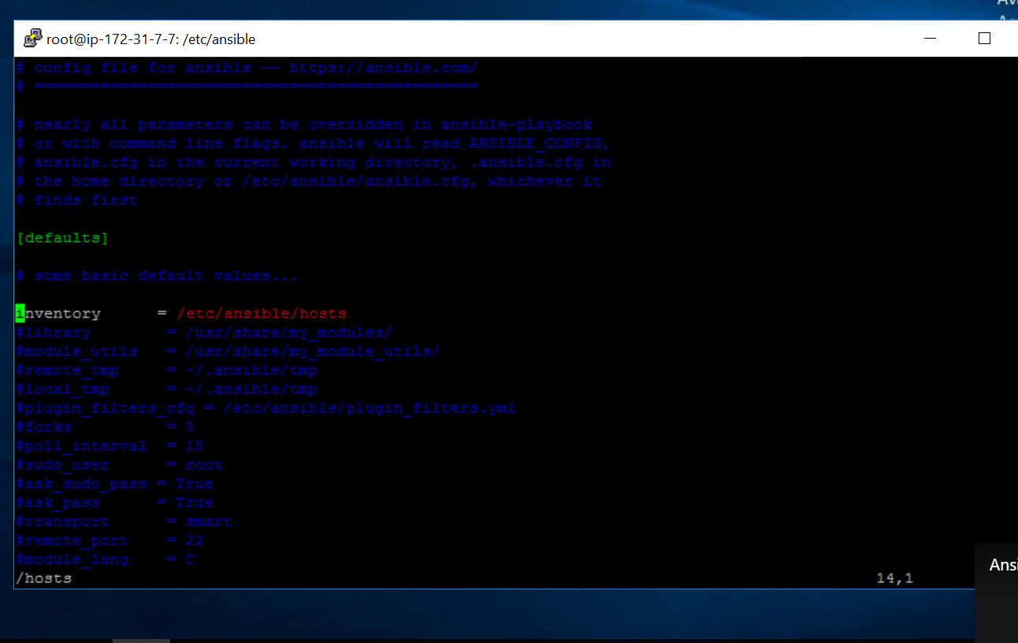

**Use boto in ansible server**

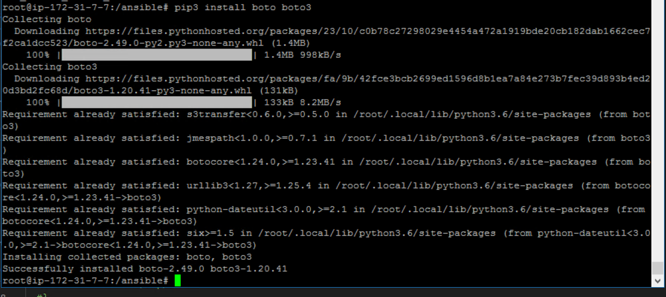

Using PIP install AWS modules in Ansible server

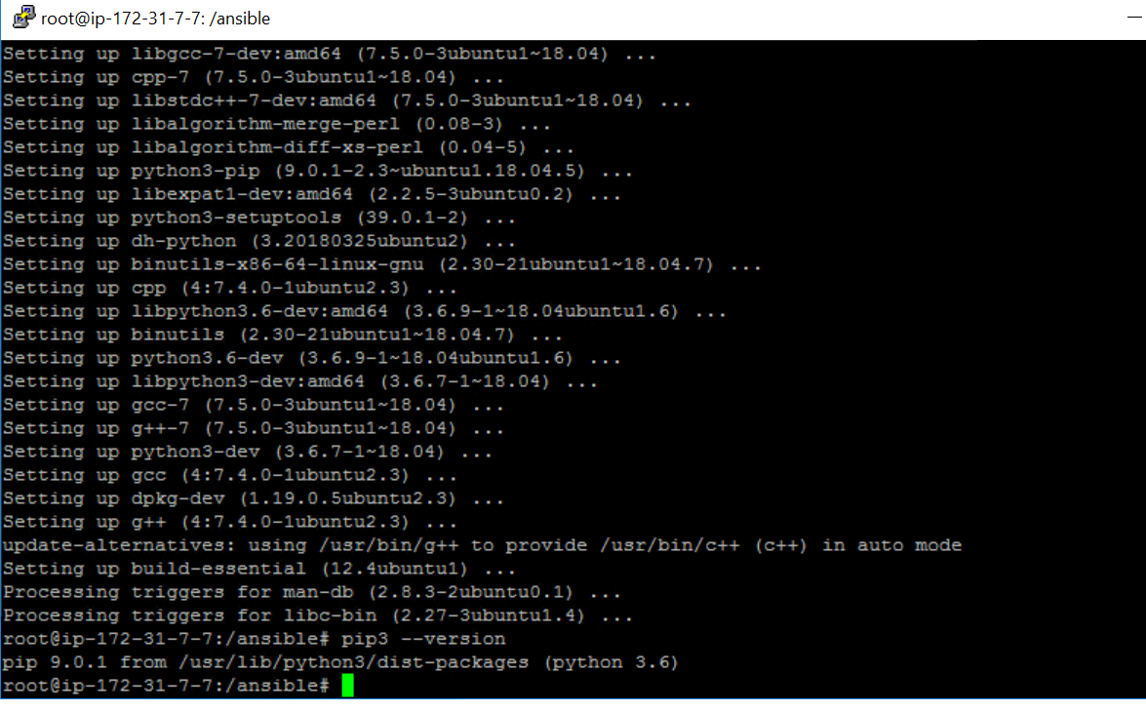

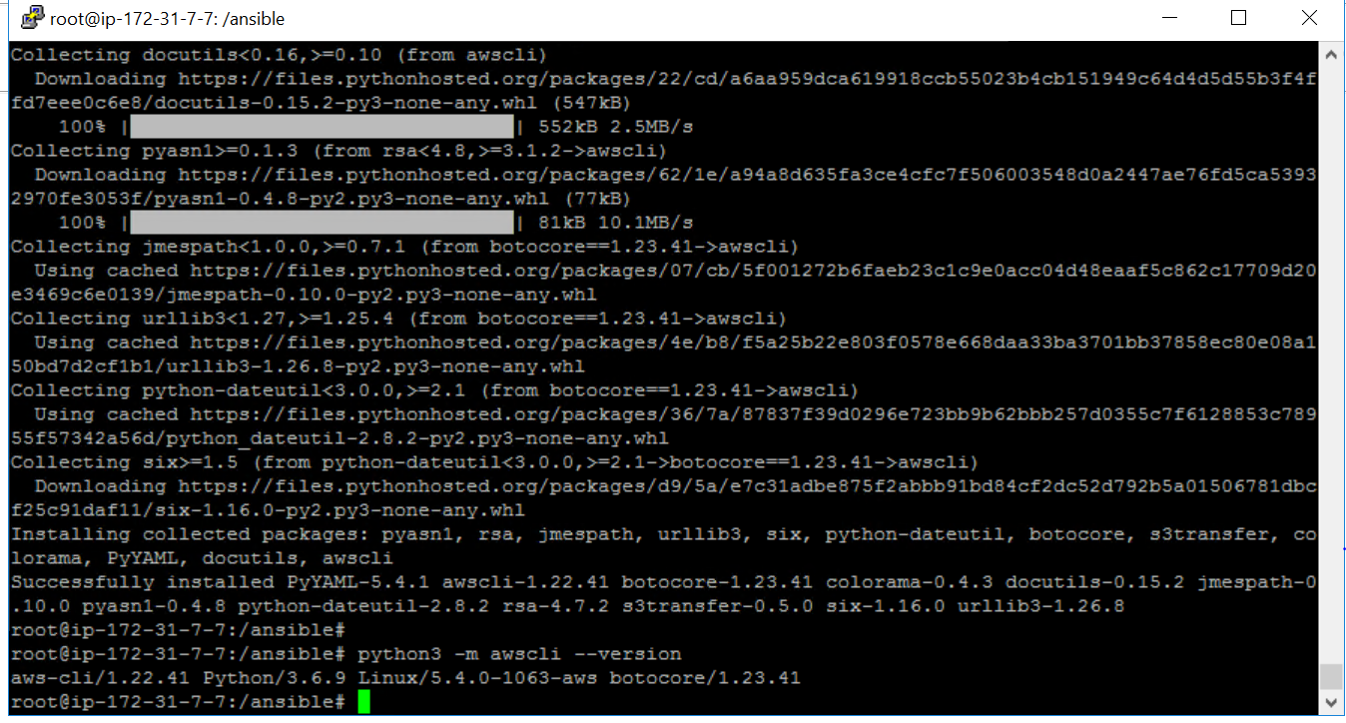

**Use the same service Principle created for terraform for ansible to get authenticated to AWS**

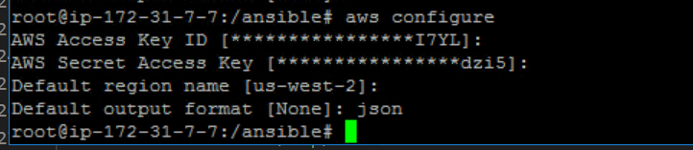

Create a playbook1 to create a vm in AWS

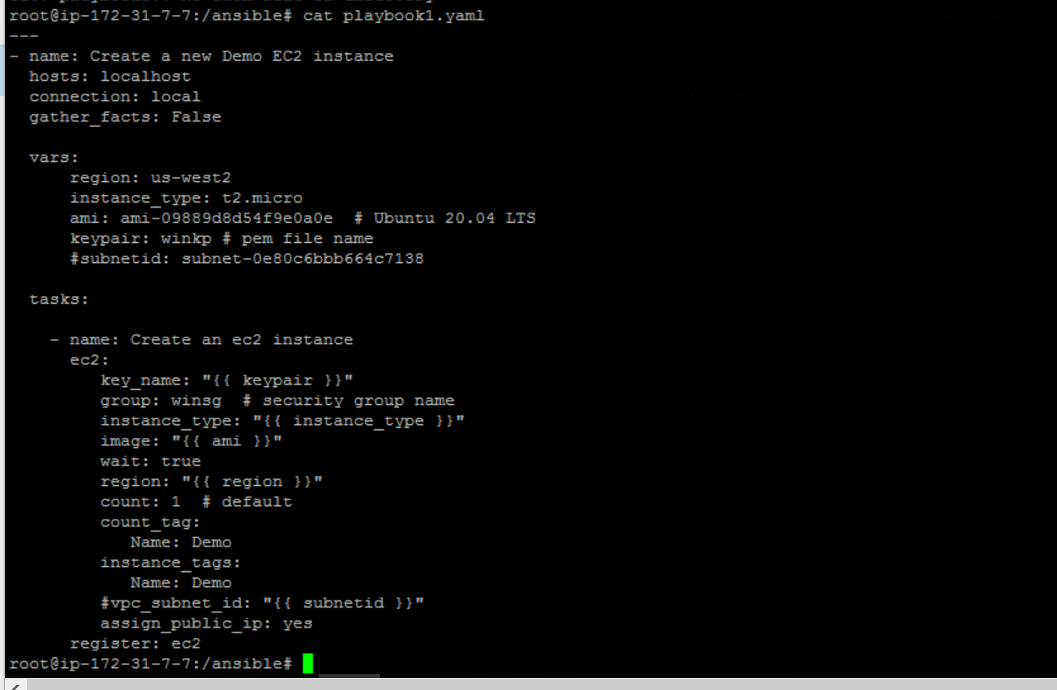

**Update the playbook2 to install Docker engine on the VM**

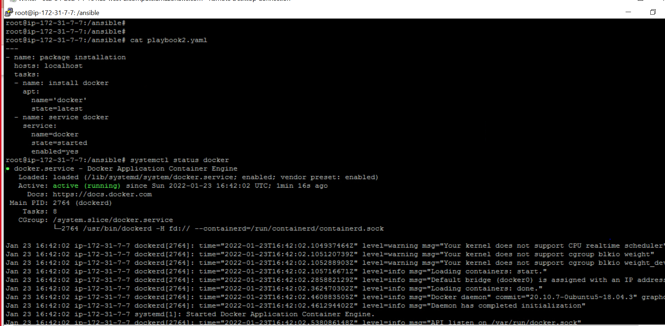

**create a shell script to get VM ip and updating it in Inventory File**

